Report to Day Star Research

Components of Resilience and Recovery on a Bleached Coral Reef

Introduction and Rationale
One the greatest concerns for coral reefs regionally and globally is the warming and acidifying affects of climate change (Baker et al. 2008). Coral are highly sensitive to temperature changes in the water, and if temperatures are sustained just 2 degrees above normal for more than a few weeks corals will expel their symbiotic zooxanthellae. This leaves the coral white or bleached, and eventually leads to starvation and death. Mass events of bleaching across whole ocean basins, such as the ENSO event in the Indian Ocean in 1998 (Ateweberhan et al. 2011), are a cause for international concern particularly in developing countries, where there is a high reliance on reef ecosystems for fish and other resources (McClanahan and Cinner 2012).

“Resilience” is the propensity of coral reef communities to “bounce back” from large-scale disturbances, such as mass bleaching (Bellwood et al. 2004). Will a reef revert back to its original condition? How long will this take? Are there intermediate stages or succession? Where are the stable states and tipping points? An understanding of resilience should allow managers to promote resilience factors and protect against threats on a local scale in order to buffer against regional or global disturbances (Bellwood et al. 2004, Hughes et al. 2003).

This project is investigating the resilience and recovery of Watamu Marine National Park (WMNP), Kenya, being structured through a PhD. This Marine Protected Area (MPA) was gazetted in 1968, making it one of the oldest marine parks in the world. In 1998 it lost 66-80% of its hard coral (Scleractinia) (Obura et al. 2000) in one of the worst mass bleaching events ever recorded where globally about 16% of the world’s coral reefs were severely affected (Hughes et al. 2003). Is Watatmu recovering? How fast? Which factors are aiding this recovery and which ones are hindering? How are the patterns and processes seen in Watamu typical to coral reefs around the world?

WMNP covers a 10km² lagoon of coral reef, seagrass and intertidal habitats and is one of five MPAs in Kenya, encompassed within the larger Watamu-Malindi Marine National Reserve, which includes the nearby Malindi Marine National Park and Mida Creek mangrove area (see Fig 1). Watamu and Kenya in general have understudied marine environments. To date, no map exists of Watamu Marine National Park with accurate habitat zones, there has not been a comprehensive fish species list completed for twenty years and there has never been complete census of corals. Much of the ecological data for the MPA has come from just three well-known patch reefs, with large areas receiving no attention. This project will provide an up to date baseline of biodiversity and ecology for the area, which is necessary to make management decisions about the conservation of this area, inform future research directions and offer insights into marine park management and science as a whole.

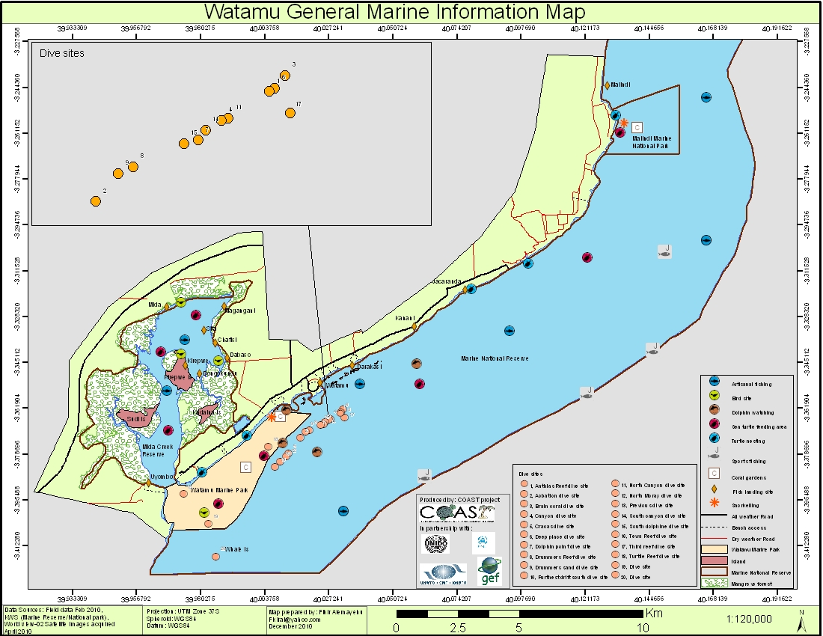
The PhD is being carried out through A Rocha Kenya (http://www.arocha.org/ke-en/), a locally based Christian Non-Governmental Organisation (NGO), which has been based in Watamu for over 10 years. A Rocha Kenya works locally focussing on the Watamu area, but is involved with a broad range of work, equipped with a range of research and conservation programmes, environmental education and conservation action with the local community. This research project is embedded within A Rocha’s Marine Research and Conservation Programme (Marine Programme), which, since starting in 2010, aims to enhance marine research and conservation action in Watamu. The Marine Programme was co-founded by the applicant, Benjamin Cowburn (BC) and hence BC has extensive experience, knowledge and working relationships in the area. Indeed, the Marine Programme is a collaborative project with Kenya Wildlife Service (KWS), the governmental body in charge of all national parks in Kenya, and has their full support and permission.
Figure 1 Map of Watamu-Malindi Marine Reserve

A wide range of baseline and preliminary data has been collected through the Marine Programme, which contributed to the inspiration and design of the current PhD. Some of the main activities and findings from this research from September 2011 until August 2013 are summarised below:

- 340 fish species and 34 coral genera have been recorded in the park
- Benthic cover and fish communities have been assessed for four patch reefs in the park
- Preliminary mapping of all coral reef areas using a hand-held GPS has been undertaken
- Coral reef resilience methods, such as adult coral population structure assessments, have begun in five patch reefs
- Bleaching surveys following a minor bleaching event in March 2013 are being carried out in three patch reefs

Objectives
Several research questions are asked during this PhD. These questions are being answered through ecological monitoring and data analysis from different patch reefs.
The PhD chapters are as follows;
- To know how coral reefs and other habitats are distributed within WMNP
To date there is no comprehensive habitat map of the marine park. The project will produce maps and GIS layers for the locations of coral reef, seagrass, sandy areas and rocky areas throughout WMNP.
- To make an up to date species list and biodiversity estimates for WMNP
The most recent species lists for WMNP are at least 20 years old and were conducted as incidental lists. This project will compile a quantitative list of fish and hard coral (Scleractinia) for seven main patch reefs in the park and produce species richness estimates for each patch and the coral reef habitat of the entire park. In addition an incidental list for all habitats across the entire park will be collected.
- To understand if there is variation between the resilience of different patch coral reefs in WMNP and other coral reefs in Kenya and East Africa
A range of resilience indicators will be collected at the seven main patch reefs in WMNP and patch reefs two other areas of Kenya, Lamu and Kisite and then Zanzibar in Tanzania and Vamizi Island in Mozambique. These include indicators of coral population, fish abundance and community structure, keystone invertebrate abundance, benthic cover, water quality and nutrient content, and temperature fluctuations. These data will be analysed to highlight key resilience indicators which appear to be strongly influencing the health of the reef.
- To understand if there is variation in mortality and growth rates of corals now compared to 20 years ago before the 1998 bleaching event
CORDIO, one of the project’s main collaborators has provided a 20 year old dataset from Watamu investigating juvenile coral growth and mortality rate. These methods will be repeated in the same locations to determine if there is a difference in juvenile coral abundance, growth and mortality rate from 20 years ago.

Describe the funding needed/available for your research:
Below are the total costs for the whole PhD as of August 2013.
Item | Unit Cost | Total amount required
University Fees | $3265 per term | $29,385
Living costs in UK | $1540 x 16 months | $24,640
Flights | $900 x 5 | $4500
Stipend | $222 x 24 months | $5328
House | $135 x 20 months | $2700
Research assistant stipend | $175 x 6 months | $1050
Research Permit | $400 | $400
Research Visa | $150 | $150
Dive Training | $1725 | $1725
DAN Insurance | $150 per year | $300
WIOMSA conference | $1200 per person | $1200
Dive Equipment | $1000 | $1000
Fieldwork, Equipment and Internal Travel | $5,000 | $5,000
Sum |  | $77,378

Main funding requirements at the moment include;
- Stipend for the research assistant $1050
- 1 Return Flight to London to Nairobi $900
- Fieldwork and Internal Travel $Flexible. There are different fieldwork options open to me depending on the amount I could receive. As we progress with the application I can explain these in more detail and get costs for this. E.g. 1 fieldwork day in Watamu costs about $20 including boat, petrol, tank fills etc. Further afield this will change e.g. in Vamizi, Mozambique the collaborator can provide tanks and a boat for free, but my daily accommodation charge is $50.

Describe your career goals/interests:
I have been fascinated by the marine world my whole life. A simple enjoyment of rockpooling and messing about as a child on the Cornish coast, in the west of England, has blossomed into a full-scale occupation in marine conservation and science. My current project in Kenya, with A Rocha Kenya is my first real foothold in the career ladder and is where I am learning the skills and gaining the experience I need to be a recognised in this field. After the first year of working with A Rocha it was decided that they would support me through a PhD, which was considered the best way for our mutual goals of achieving relevant, comprehensive and academically sound marine research. My hope is that a successful completion of this PhD and project in Kenya will give me all the foundation I need to continue my lifelong passion in marine science and conservation.

Describe your Christian background/experience/goals:
I became a Christian at the age of 15 while attending a youth camp in Wales. I come from a non-religious, non-church going family, so it was quite an unusual move for a teenager like me to start going to church. However I felt a strong pull to a church and I started to go.
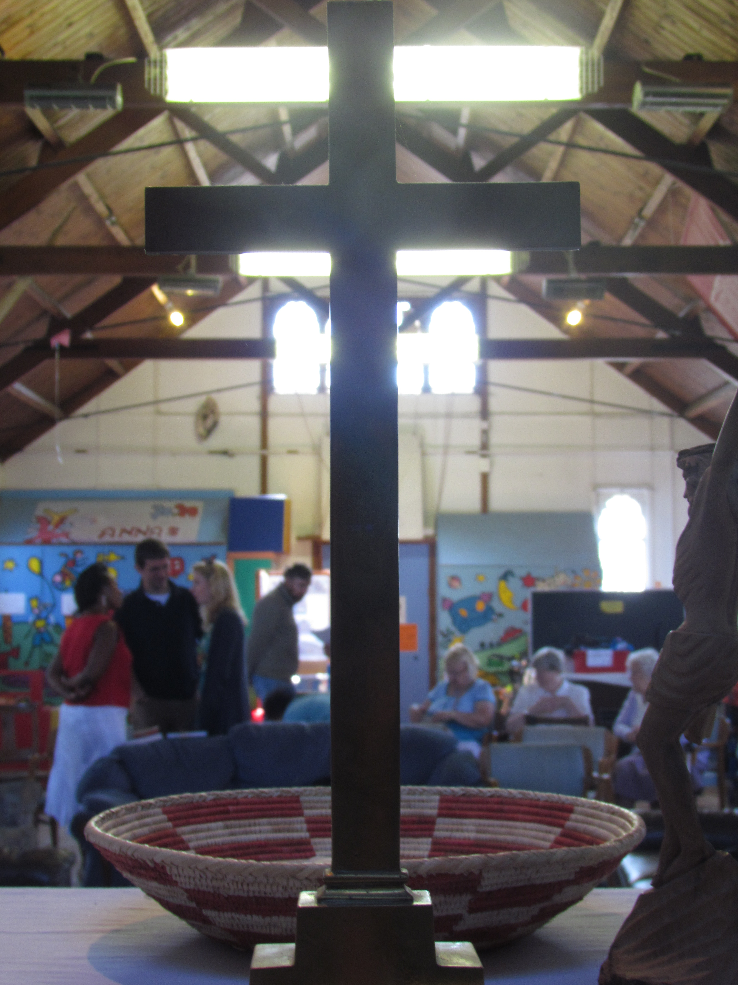
Through university I matured a lot in my faith, especially when I started to attend St. Luke’s Church, Oxford. St. Luke’s is mixed community of young and old, white and black, with people at all different stages of faith development and theology. It is a really small church of only 40-50 people and we conduct services in a small unimpressive wooden building, sitting on sofas and armchairs for the service. Everyone was welcome, everyone was accepted and everyone was loved. While at university one tends to only interact to other like-minded young people, but at St. Luke’s I had to learn how interact and love people I wouldn’t necessarily choose to. I think this community is the closest I have ever experienced, which reflected some of the principals of the early church in Acts. I have two god-daughters through this church and consider them my home church even now as I live in Kenya.

My second major development in my faith was joining A Rocha. A Rocha are an international Christian conservation charity based in 20 countries including the UK, USA and Kenya. The organisation focuses its work on conservation science and action in the different areas it works, but with the majority of staff being Christian and hence the motivation and beliefs behind our work stemming from Christian principals. On leaving university this was exactly the kind of organisation I wanted to work with, where one minute you can be really nerdy about awesome sea-creatures and in the same breath praise God for his creation. A Rocha have a range of well thought out theologies, which are written in some of the books members have written, about creation care, the environment and poverty alleviation, and other aspects of our work relevant to faith and the bible. This means that as I have increased my research and scientific experience, this has gone hand in hand with biblical truths about the world, our work and the redemption for humans and creation through Jesus Christ.

Through St. Luke’s and A Rocha I have received a lot of spiritual and practical support from a loving network of people. This has given me a very practical basis for my faith, with a lot of experience of how faith directly impacts my relationships and my work. Now I have received this solid foundation, I hope to use these principals and lessons to encourage other young Christians and scientists, while continuing to balance work, church, community and family in my day-to-day life.

Describe your views of creationism and Intelligent Design, and the proper relationship between science and your Christian faith:
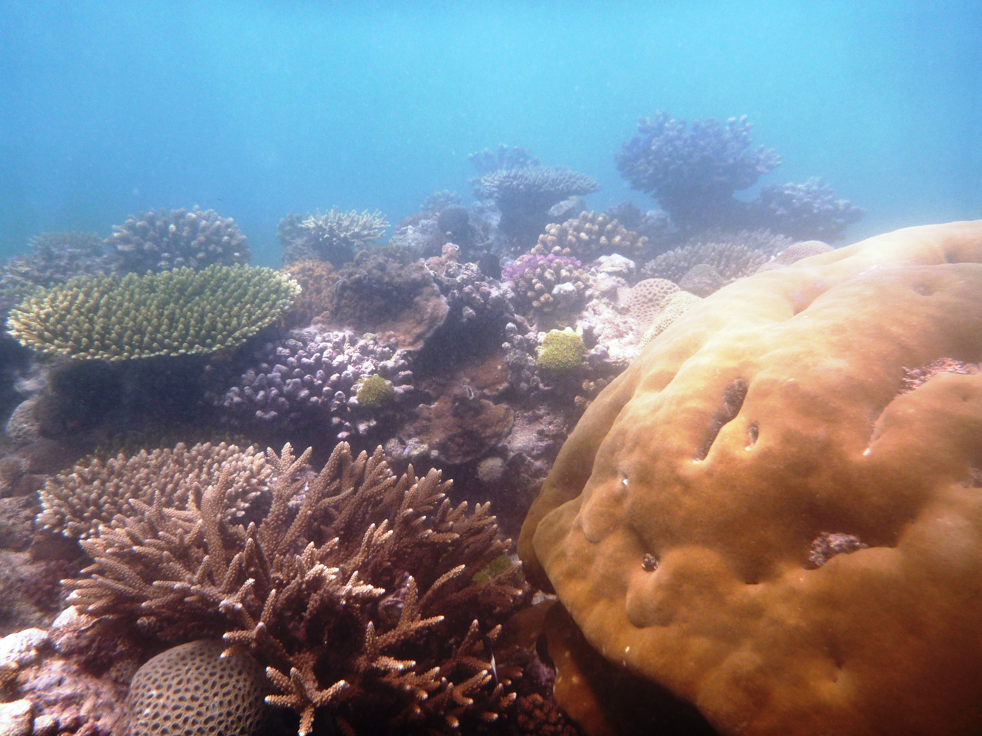
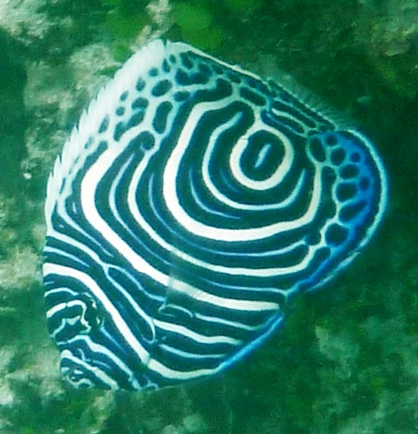
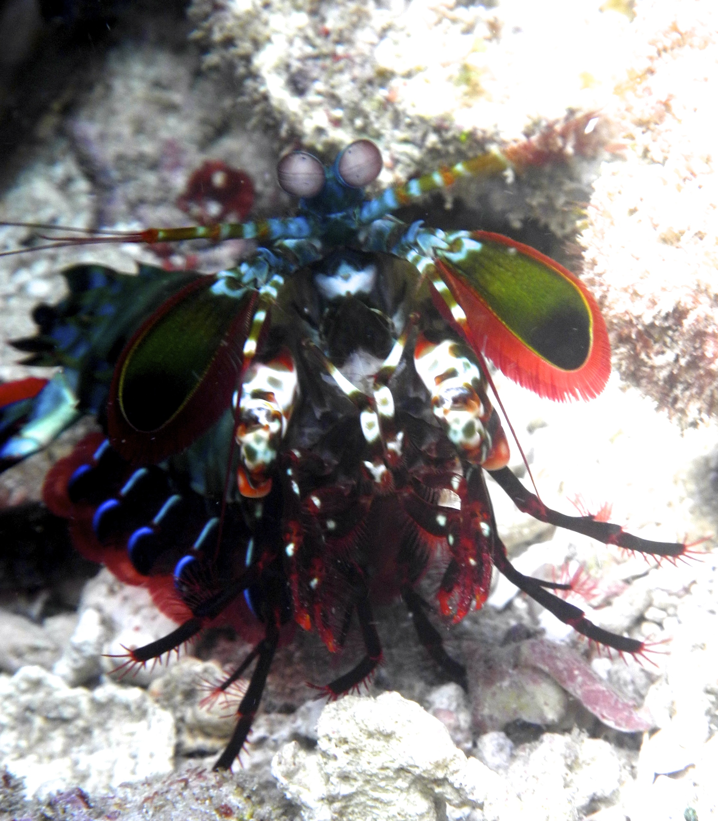
Working on coral reefs I am lucky enough to see God’s creation at it’s most artistic. Each creature is adorned with complex colours and patterns that together make a stunning canvas, which praise their creator and point to His glory. Psalm 148 v 7: Praise the Lord from the earth, you great sea creatures and all ocean depths. We are told in Genesis that when God made the world he declared in good, from the fish of the sea, to the birds in the sky and at last man himself. He created the world to reflect his glory and this extends to every part of creation and not just humans, as we as Christians can so often assume.

Christians who are involved in science should play a very similar role to Christians in any other field of work. We should work diligently and responsibly, recognizing that when we use the skills He has given us, our work is giving glory and worship to Him. Through our work and attitude we should be the “salt and light” to those we work with.

I don’t think that there is any need for Christianity and Science to battle. Science is concerned with the careful intellectual study, whereas Christianity centres around transforming lives and reorienting ourselves towards God and the eventual redeeming of Heaven and Earth. Personally I have never found these separate aspects of my life to clash. Most scientists recognize that they don’t have all the answers and there is so much more to discover. I think more Christians need to have this attitude and at the same time put more effort into the mission laid out in the New Testament, which doesn’t include a command to convince people the earth is only 7000 years old, but rather that they are loved and cherished children of the eternal and glorious Father in heaven.

